Bank Loan Report Analysis

📖 Project Overview
The Bank Loan Report Analysis project is a comprehensive banking analytics solution built using SQL and Business Intelligence concepts. The project analyzes loan application data to provide insights into lending performance, repayment behavior, loan quality, and borrower characteristics.
The dashboard helps stakeholders monitor portfolio health, identify risk patterns, evaluate loan performance, and make data-driven lending decisions.

🎯 Business Objective
Banks handle thousands of loan applications and active loans. This project aims to:
- Monitor loan portfolio performance.
- Analyze loan application trends.
- Track funded and recovered amounts.
- Identify good and bad loans.
- Evaluate borrower demographics and risk factors.
- Support strategic lending decisions.

🛠️ Tools & Technologies
- SQL Server
- SQL Server Management Studio (SSMS)
- Power BI / Tableau
- Microsoft Excel
- GitHub

📂 Dataset Information
Table Name: bank_loan_data
The dataset contains information related to:

Borrower Details
- Loan ID
- Address State
- Employee Length
- Employee Title
- Home Ownership
- Annual Income

Loan Details
- Loan Amount
- Interest Rate
- Instalment
- Loan Term
- Loan Purpose

Credit Information
- Grade
- Sub Grade
- Verification Status
- Debt-to-Income Ratio (DTI)

Loan Performance
- Loan Status
- Issue Date
- Last Payment Date
- Next Payment Date
- Total Payment

📊 Dashboard 1: Summary Report
The Summary Dashboard provides a high-level overview of lending performance.

Key Performance Indicators (KPIs)

Loan Applications
- Total Loan Applications
- Month-to-Date (MTD) Applications
- Previous Month-to-Date (PMTD) Applications

Funded Amount
- Total Funded Amount
- MTD Funded Amount
- PMTD Funded Amount

Amount Received
- Total Amount Received
- MTD Amount Received
- PMTD Amount Received

Interest Rate Analysis
- Average Interest Rate
- MTD Interest Rate
- PMTD Interest Rate

Debt-to-Income Analysis
- Average DTI
- MTD DTI
- PMTD DTI

Good Loan Analysis

Good Loans Include
- Fully Paid
- Current

Metrics
- Good Loan Percentage
- Good Loan Applications
- Good Loan Funded Amount
- Good Loan Amount Received

Formula
(COUNT(Good Loans) * 100.0) / COUNT(All Loans)

Bad Loan Analysis

Bad Loans Include
- Charged Off

Metrics
- Bad Loan Percentage
- Bad Loan Applications
- Bad Loan Funded Amount
- Bad Loan Amount Received

Formula
(COUNT(Bad Loans) * 100.0) / COUNT(All Loans)

Loan Status Analysis
The report provides a detailed breakdown by loan status including:
- Loan Count
- Total Funded Amount
- Total Amount Received
- Average Interest Rate
- Average DTI

📈 Dashboard 2: Overview Report
The Overview Dashboard provides detailed segmentation and trend analysis.

Monthly Trends
Measures:
- Total Loan Applications
- Total Funded Amount
- Total Amount Received
Purpose:
- Identify seasonal lending trends.
- Monitor business growth over time.

State Analysis
Measures:
- Loan Applications by State
- Funded Amount by State
- Amount Received by State
Purpose:
- Analyze geographic distribution of lending activities.

Loan Term Analysis
Categories:
- 36 Months
- 60 Months
Purpose:
- Compare short-term and long-term lending performance.

Employment Length Analysis
Measures loan performance based on employment duration.
Purpose:
- Evaluate borrower stability and repayment potential.

Loan Purpose Analysis
Examples:
- Debt Consolidation
- Credit Card
- Home Improvement
- Education
- Small Business
Purpose:
- Understand borrower intentions and lending demand.

Home Ownership Analysis
Categories:
- Rent
- Mortgage
- Own
- Other
Purpose:
- Assess borrower financial stability.

📋 Data Dictionary

Loan ID
Unique identifier assigned to each loan application.

Business Use
Used to track and manage loans throughout their lifecycle.

Address State
Borrower's state of residence.

Business Use
Helps identify regional lending trends and risk exposure.

Employee Length
Duration of borrower's employment.

Business Use
Measures employment stability and repayment capability.

Employee Title
Borrower's occupation.

Business Use
Used to verify income sources and employment information.

Grade
Loan risk classification.

Business Use
Used for risk assessment and interest rate determination.

Sub Grade
Detailed risk category within a grade.

Business Use
Provides more granular borrower risk segmentation.

Home Ownership
Borrower's housing status.

Business Use
Used to assess financial stability and risk.

Issue Date
Date when loan was issued.

Business Use
Used for portfolio aging and trend analysis.

Loan Status
Current status of loan.
Examples:
- Fully Paid
- Current
- Charged Off

Business Use
Measures loan performance and portfolio health.

Purpose
Reason for obtaining the loan.

Business Use
Used to analyze customer borrowing behavior.

Term
Loan repayment duration.

Business Use
Used to evaluate maturity structure of the loan portfolio.

Verification Status
Income verification status.

Business Use
Measures credibility of borrower information.

Annual Income
Borrower's yearly income.

Business Use
Used to determine repayment capability and eligibility.

Debt-to-Income Ratio (DTI)
Ratio of debt obligations to income.

Business Use
Assesses borrower affordability and credit risk.

Instalment
Fixed monthly payment amount.

Business Use
Used to evaluate affordability and repayment schedules.

Interest Rate
Annual borrowing cost.

Business Use
Determines profitability and risk pricing.

Loan Amount
Principal amount borrowed.

Business Use
Represents lending exposure and portfolio size.

🚀 How to Run the Project

Step 1
Create a SQL Server Database.
CREATE DATABASE BankLoanDB;

Step 2
Import the dataset into SQL Server.

Step 3
Execute the SQL queries provided in the project.

Step 4
Connect Tableau to the SQL database.

Step 5
Build the dashboards using the generated KPIs and reports.

📸 Dashboard Screenshots

Summary Dashboard
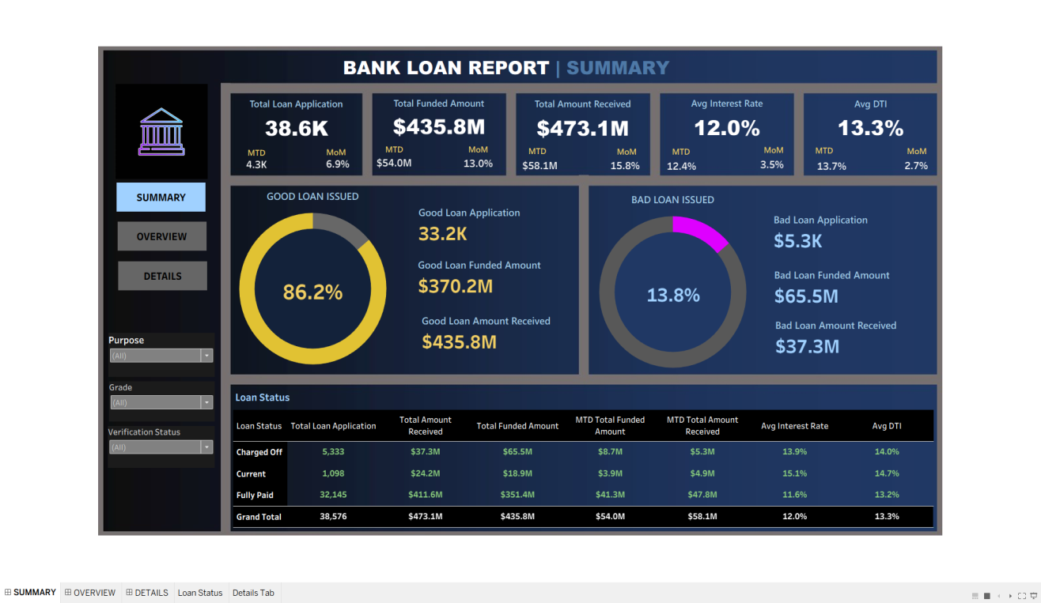

Overview Dashboard

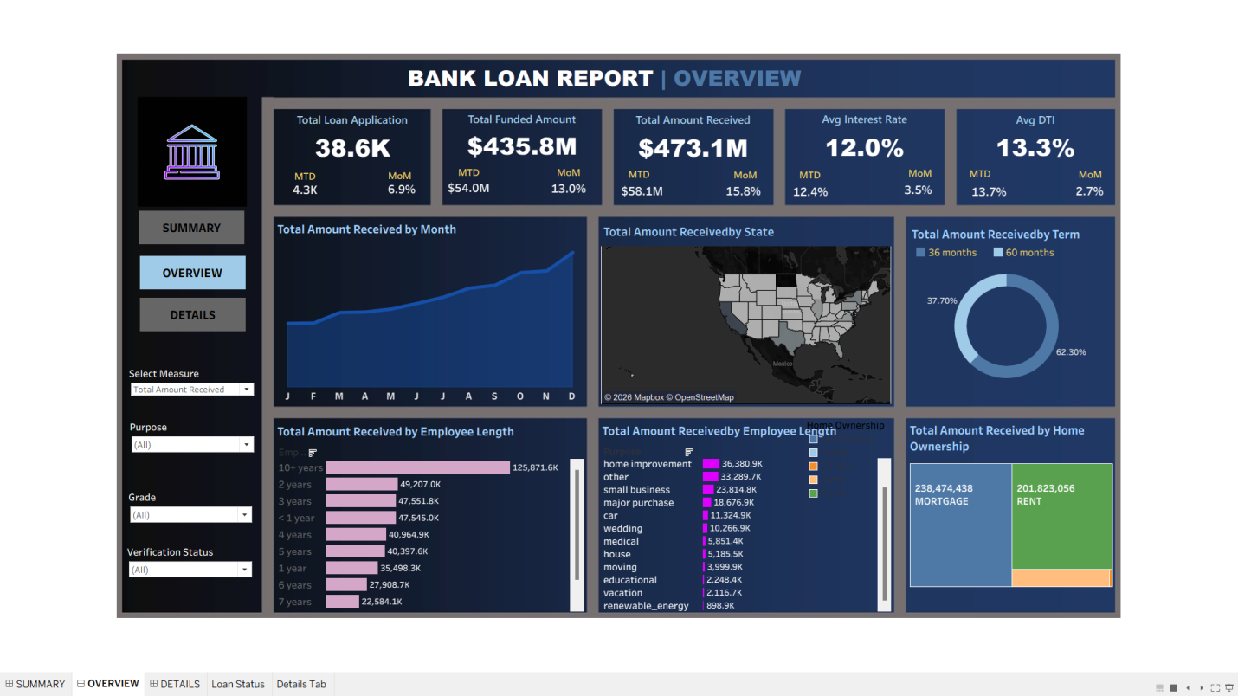

💡 Key Insights
- Track total lending activity and growth.
- Measure loan repayment performance.
- Identify high-risk and low-risk loan segments.
- Analyze borrower demographics.
- Evaluate regional lending trends.
- Monitor portfolio health and credit exposure.

🔮 Future Enhancements
- Loan Default Prediction Model
- Credit Risk Scoring Dashboard
- Customer Segmentation Analysis
- Real-Time Data Integration
- Branch Performance Analytics
- Machine Learning-Based Risk Assessment

👨‍💻 Author
Disha Pramanick
- LinkedIn: www.linkedin.com/in/disha-pramanick-96545a380

⭐ Project Highlights
✔ Banking Domain Analytics
✔ SQL Data Analysis
✔ KPI Dashboard Reporting
✔ Loan Portfolio Analysis
✔ Credit Risk Monitoring
✔ Business Intelligence & Visualization

